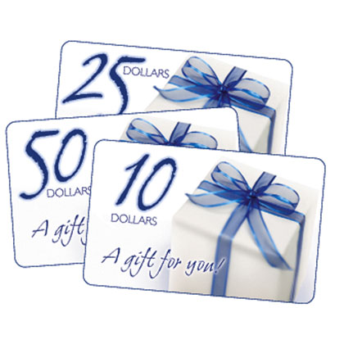
Online Gift Cards Are Now Available at M.J.C. through the Parents Association
It is Easy, Fast, and Available all year long!
- Go to www.shopwithscrip.com
- Click on family signup and then click on create an account.
- Next fill out all the necessary info and set up an account.
- You will see “join a nonprofit”. Underneath will be a box marked “enrollment code”. Enter A3897D5229989 and then click on join.
- Now you will be able to order your gift cards online through M.J.C.
- All money for gift cards must be checks payable to M.J.C and sent to the office after you order your gift cards online. Please Label the envelope Attention Melanie or Steven Green.
- For those of you who are not comfortable ordering online we also have a printed list of gift cards that are available and a printed order form. These also get sent to the office with a check payable to M.J.C and marked attention Melanie or Steven Green.
- No gifts cards will be sent to us unless we send them a check first.

